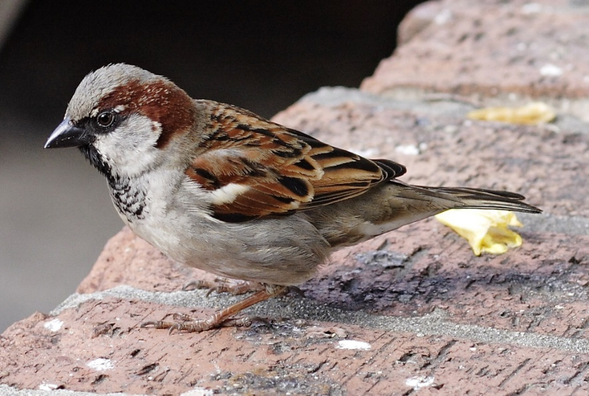

[This Photo](https://commons.wikimedia.org/wiki/File:House_sparrowII.jpg) by Unknown Author is licensed under [CC BY-SA](https://creativecommons.org/licenses/by-sa/3.0/)

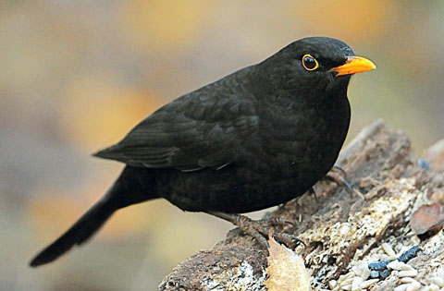

[This Photo](http://www.scp-wiki.net/scp-1948) by Unknown Author is licensed under [CC BY-SA](https://creativecommons.org/licenses/by-sa/3.0/)

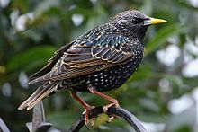

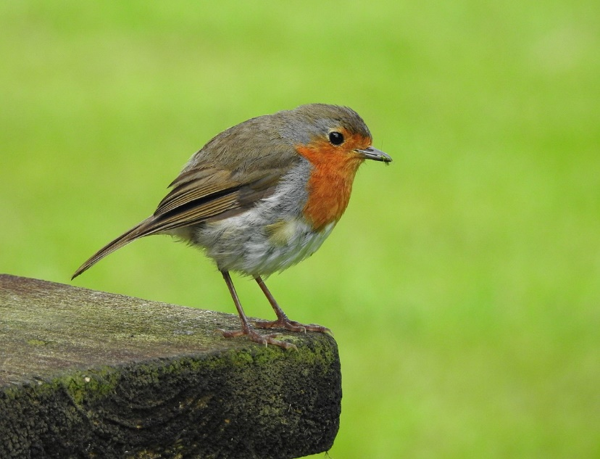

[This Photo](https://en.wikipedia.org/wiki/European_robin) by Unknown Author is licensed under [CC BY-SA](https://creativecommons.org/licenses/by-sa/3.0/)

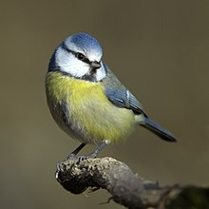

[This Photo](https://simple.wikipedia.org/wiki/Blue_Tit) by Unknown Author is licensed under [CC BY-SA](https://creativecommons.org/licenses/by-sa/3.0/)